Geography in English
Part #1
Physical Geography
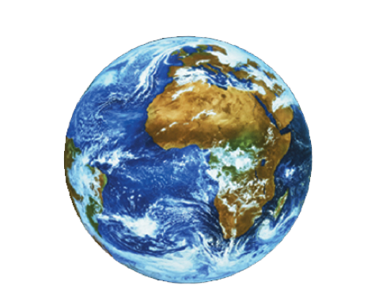

Gymnázium pod Svatou Horou
Příbram

Mgr. Hana Malátková
September 2016/January 2017

1 Structure of the Earth

The earth consists of:
- Inner core – it is solid, consists of iron and nickel
- Outer core – liquid, consists mainly of iron, movements in the outer core probably make the earth’s magnetic field
- Lower mantle – is solid
- Upper mantle – is liquid
- Crust – solid, divided into two different types: continental (25-70 km deep) and oceanic (6 km deep)

Task 1 – Match parts of the earth with the picture
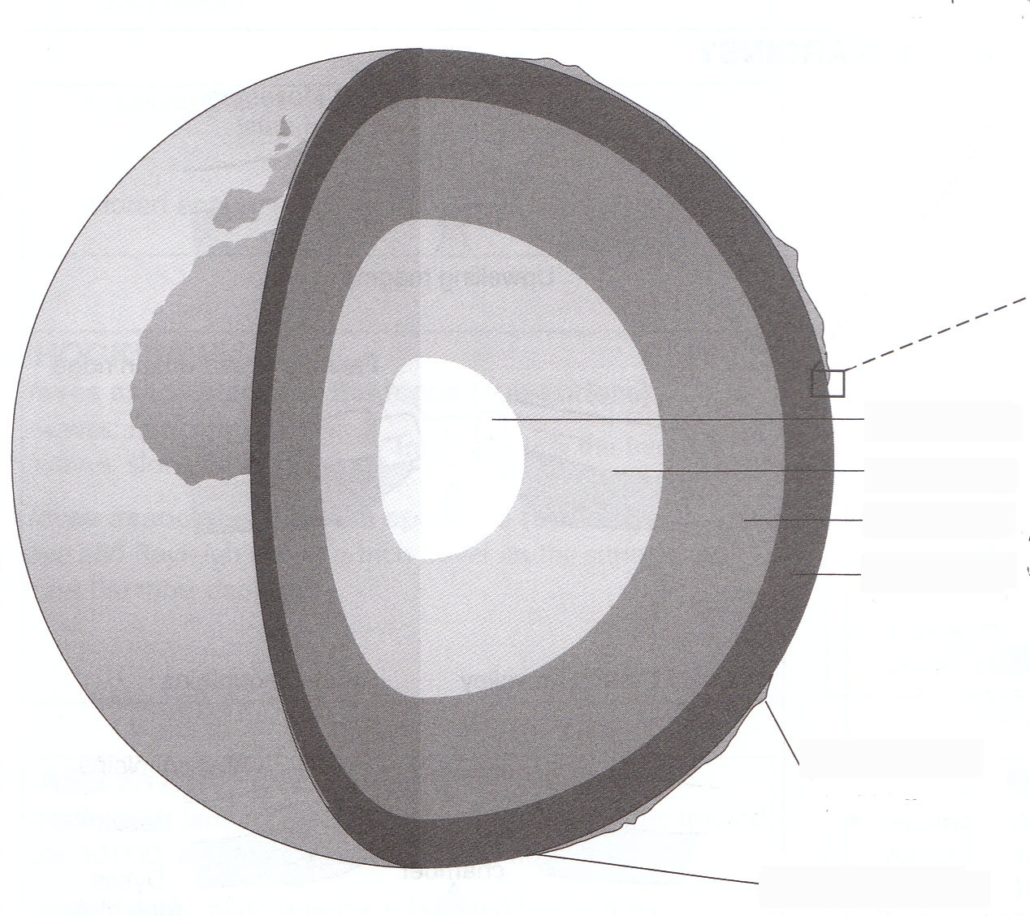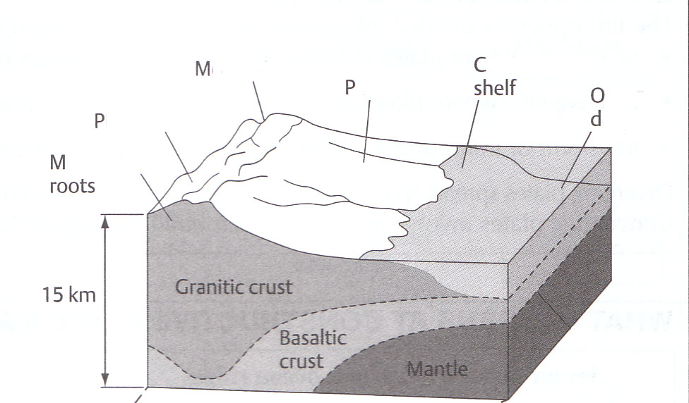
Picture no.1 Structure of the eart Picture no.2 Coastal crust
Task 2 – Complete the text
The continental crust is beneath ................... and is composed of ....................... (kind of stone). The depth between the land and the mantle is 15 km on average. The sea bottom is composed of the ................ crust.
It appears that the oceanic crust plunges down beneath the continetal crust.
The tectonic plates lie on the litophere and move.
Key vocabulary:
English | English definition Czech

2 Plate Tectonics
- It is a set of theories which explains the distribution of earthquakes, volcanoes and fold mountains
- It says that the earth’s core consists of semi-liquid magma and that the earth’s crust moves around on the magma
- The tectonic plates are the outer layer and they are like “jigsaw pieces”
- They [the plates] move only a few mm per year

Picture 1 The plates

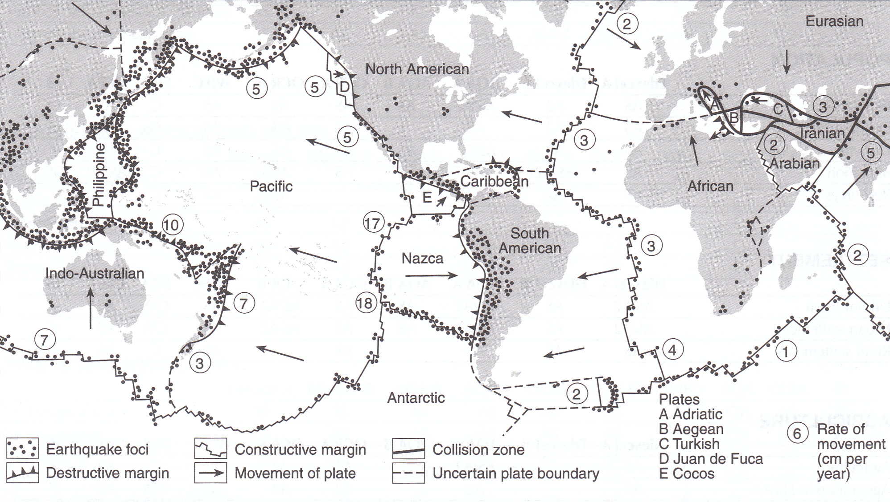
- Name some tectonic plates and show their border
- Describe where the plates move the most per year
- Show and name areas where the earthquakes occur the most

Picture 2 Types of boundary
- 2) 3)
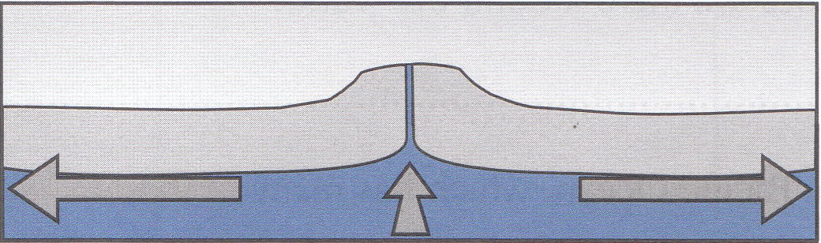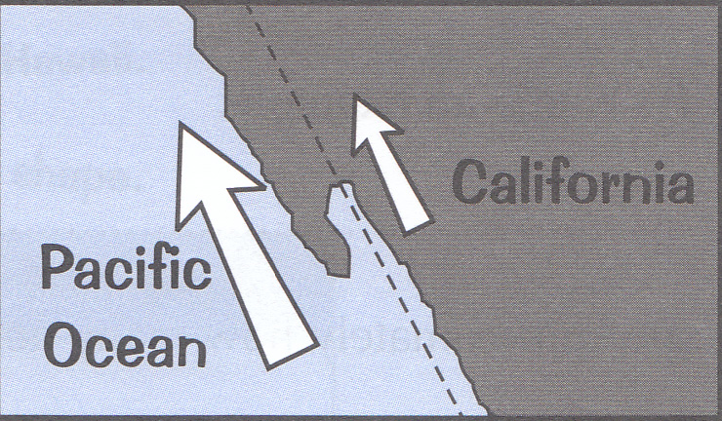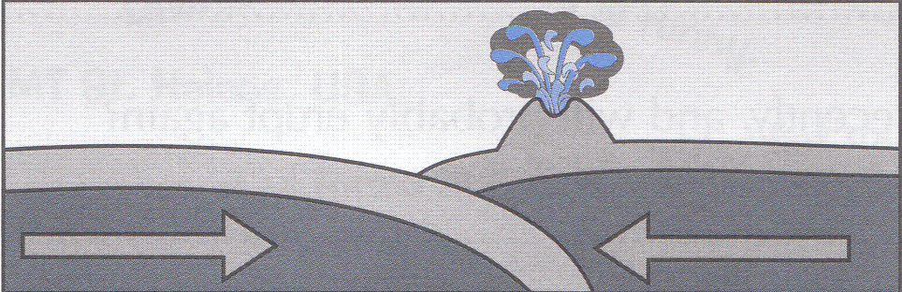

Type of boundary | Processes | Example | No. of picture
Constructive zone (divergent) | - Two plates move apart from each other  - New oceanic crust is formed
Destructive zone | - The oceanic crust moves towards the continental and sinks beneath
Collision zone | - Two crusts collide

The evidence for plate tectonics:

Vocabulary
English | Explanation | Translation

3 Volcanoes
- is an opening in the earth’s crust through which magma, molten rock and ash are erupted onto the land
- are usually conical in shape
- mostly they are located at the edges of plate boundaries although some might be found in the interior of plates

Task 1 Complete the description of the volcano
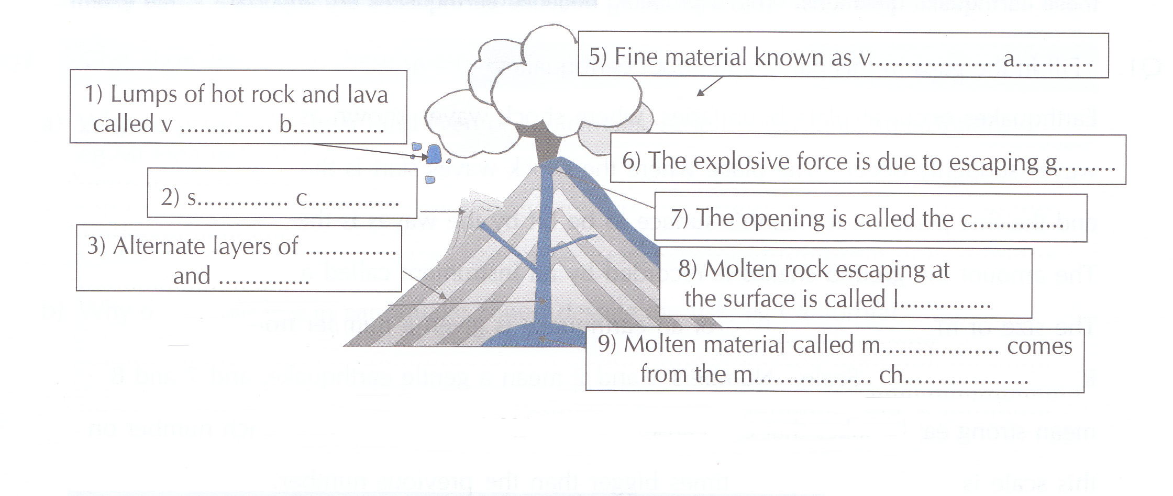
Complete these words into the sentences: dormant extinct active
............ volcano is a volcano that is very old and has never erupted in recorded history.
........... volcano is “sleeping” and may erupt again.
............. volcano has recently erupted and will probably erupt again.

Guess how many volcanoes there are around the world : your guess ................, correct answer ................
World’s explosive volcanoes
Place | Date
Tambura, Indonesia | 1815
Krakatoa, Indonesia | 1883
Katmai, U.S.A. | 1912
Mt St Helens, U.S.A. | 1980
Mt Pinatubo, The Philippines | 1991

English | Explanation | Translation

4 Earthquakes

Task 1 Complete the text
Earthquake is a ........................... of the earth’s crust which comes naturally and from ............. the surface. The place where the shock wave starts is the ................................... and the first place on the Earth’s surface to be hit by the seismic waves is the ....................................... The amount of the shakes is recorded by an instrument called a ................................. The size or magnitude of an earthquake is given a number from the R........................... Scale. Numbers 1 and 2 mean a .................. earthquake and 7 and 8 mean strong earthquakes that can cause a lot of death and destruction.

Task 2 Name the factors affecting the damage
Factors affecting damage

Task 3 Complete the tasks
- From this list, circle three places where people are most at risk from earthquakes
JAPAN GREAT BRITAIN CALIFORNIA HOLLAND MEXICO
- Explain why in LEDCs, such as India, do earthquakes kill more people than in MEDCs
LEDCs = Less Economically Developed Countries (countries of the “south”)
MEDCs = More Economically Developed Countries (the “north”)
...............................................................................................................................................................................
- Earthquakes in California (e.g. Los Angeles 1994) cause a lot of expensive damage. Why?
...............................................................................................................................................................................
- In residential areas, more deaths occur if an earthquake happens at night than during the day. Why?
...............................................................................................................................................................................
- Why is an earthquake in Alaska less of a hazard to people than one in California?
...............................................................................................................................................................................

Surviving Tectonic Hazards
Answer the following questions:
- Why do people live near (or even on) volcanoes although there is a risk of an eruption?
- Why do people live in earthquake zones, despite the risk (e.g. California)?
- How can people plan and be prepared if there is a disaster from an earthquake or volcanic eruption?

5 Weathering
It is the breakdown of rocks by physical, chemical and biological processes.

Physical weathering
Task 1 : The underlined words are wrong, write the correct versions
In climates such as the Czech Republic, it can be around freezing point 3˚C/......... in summer/.................. at night. Soup/......... can be present in cracks in rocks and when it freezes, it becomes smaller/.............During the day, the water melts and becomes bigger/.................This can happen again and again making the rock stronger/................. until the rock breaks off.

Biological weathering
Task 2: Write examples of biological weathering
....................................................................................................................................................................................................................................................................................................................................................................................................................................................................................................................................................................................

Chemical weathering
Task 3 : Where can you find examples of chemical weathering and what chemical causes it?
............................................................................................................................................................................................

Task 4: Name the type of weathering that is in the pictures

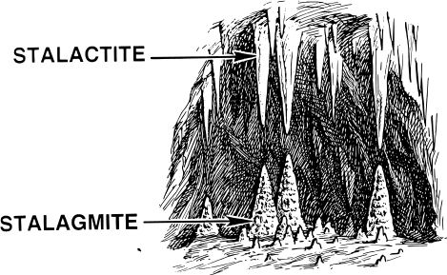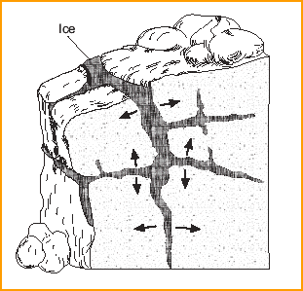
......................... weathering ............................. weathering

Task 5: Match the synonyms and write their translation
become bigger contract
become smaller weaken
make less strong expand

6 Waters

The Hydrological Cycle = the water cycle
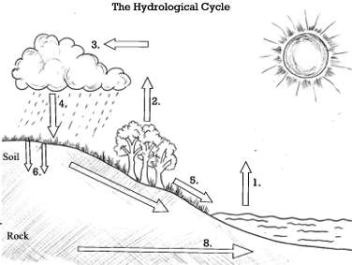
Task 1 : Name all the processes of the hydrological cycle
Evaporation, precipitation, overland flow, infiltration to groundwater, groundwater discharge, movement of water vapour from ocean to land, evaporation and transpiration, precipitation
The hydrological cycle describes what happens to water on the planet. Over the sea, water ......................... into the air as ................ .................., which then ...................... and .........................., causing ...................... and the formation of ....................... Eventually, precipitation (e.g. ..................., ................................. or ....................) falls.

World Rivers : label the greatest world rivers
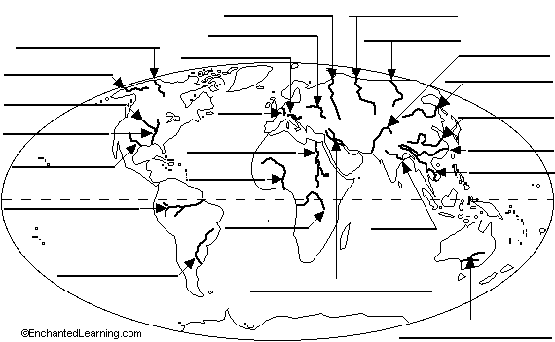

7 Power of the sea

Task 1 Complete the table

Ways in which the sea helps people | Ways in which the sea is harmful to people | Action to prevent the damage

Task 2 Decide which sentences are true and which are false
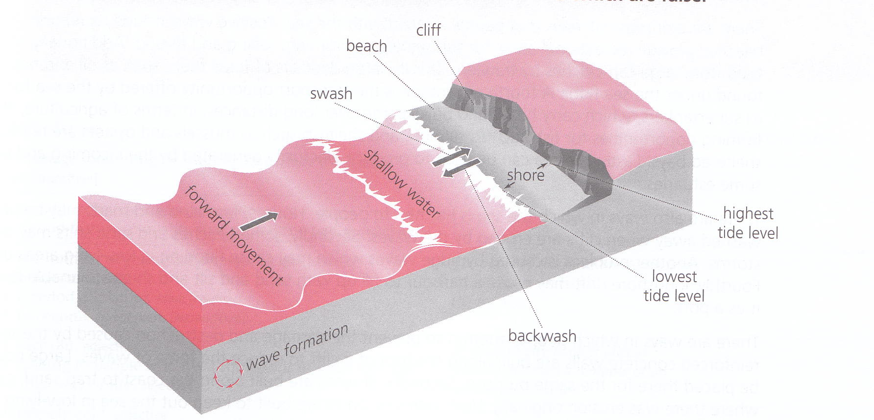
- Waves are formed when wind moves over the surface of the water and causes the water to make a circular motion which forms a wave shape. TRUE/FALSE
- It is this wave shape and not the water which moves forward. TRUE/FALSE
- When waves reach deep water they break. TRUE/FALSE
- Only then the water rushes towards the shore. TRUE/FALSE
- The swash is the rush of water down the shore following the breaking of a wave. TRUE/FALSE
- The backwash is the return movement of water up the shore. TRUE/FALSE

Task 3 Vocabulary revision – write new words you have learnt in this lesson
New word | Meaning in English | Czech translation

8 Glaciers

Task 1 Give examples of regions/countries where on the Earth you can find glaciers
Asia – ..................................................................................................................................................................
Americas – ..................................................................................................................................................................
Europe – ..................................................................................................................................................................
Africa – ..................................................................................................................................................................
Oceania – ..................................................................................................................................................................
Antarctica – ..................................................................................................................................................................

Task 2 Complete the basic information
Life of a glacier - Where can a glacier survive?

What types of glaciers exist?

Growing years – How does a glacier form?

What is “firn”?
Why does a glacier look kind of blue?

Moving glacier – How does a glacier move?

What impact does a moving glacier have on a surrounding landscape?

Glaciers in retreat – When does a glacier start retreating?

Which glaciers in particular have tended to retreat a lot in the past 100-50 years and why?

Interesting facts about glaciers:
-
-
-

9 World Climate

Task 1 The following figures give a description of Britain’s climate
 | Jan | Feb | Mar | Apr | May | Jun | Jul | Aug | Sep | Oct | Nov | Dec
degrees ˚C | 5 | 6 | 7 | 9 | 11 | 14 | 15 | 16 | 14 | 11 | 8 | 6
mm | 96 | 76 | 51 | 56 | 61 | 54 | 79 | 76 | 76 | 86 | 107 | 110

- State the maximum and minimum temperatures max......................... min .......................
- State the annual (yearly) temperature range ...........................
- Is there a dry season (yes/no)? ........................
- Does most rain fall in summer or winter? .......................

Task 2 General climate questions
- What usually happens to temperatures as you go towards the poles (known as the effect of latitude)? Why does this happen? ...............................................................................................................................................................................
- What effect does altitude have on temperatures and rainfall?
...............................................................................................................................................................................
- How does the temperature of inland areas differ from areas on the coast
- In summer? .........................................................................................................................................
- In winter? .........................................................................................................................................
- Why is this? .........................................................................................................................................
- Which areas have a greater temperature range – inland or coastal areas? .........................................................
- What often happens to the amount of rainfall as you go further inland? Why is this?
...............................................................................................................................................................................
- The factor which is described in questions 3, 4 and 5 is called? .........................................................................
- Describe how prevailing winds affect the temperature and rainfall of places.
...............................................................................................................................................................................
- As a summary of all this, complete the following:
The five factors which affect the climate of a place are
- L....................................... b) A..................................... c) C......................................
- P..................... W..................... and P..............................

